**Reflection of Week-2**

**In this week, MongoDB was introduced, where I can store data in document format. It is flexible, fast and can scale easily. In this week, I learn to insert file and edit file in MongoDB. I learn to insert additional data, I can uploaded file and edit the data in that file. I also learn about Aggregation. There are three methods of aggregation i.e aggregation pipeline, the map-reduce function, and single purpose aggregation methods. Among them, we learned about aggregation pipeline.**

**Overall, the key insight, which I gained in this week, is that I learned to match data with specific keywords. Moreover, I used MongoDB to perform calculation by giving some commands.**

**The result of lab task are**

1. **To display data of people, which have done Masters and display Minimum, Maximum and Average Age and Minimum, Maximum and Average of that People.**

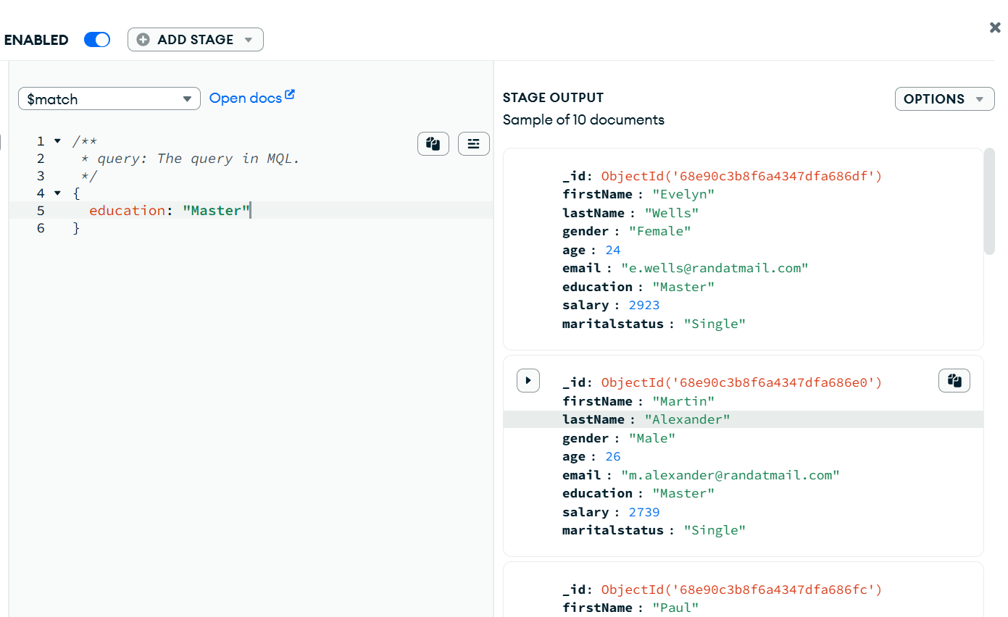

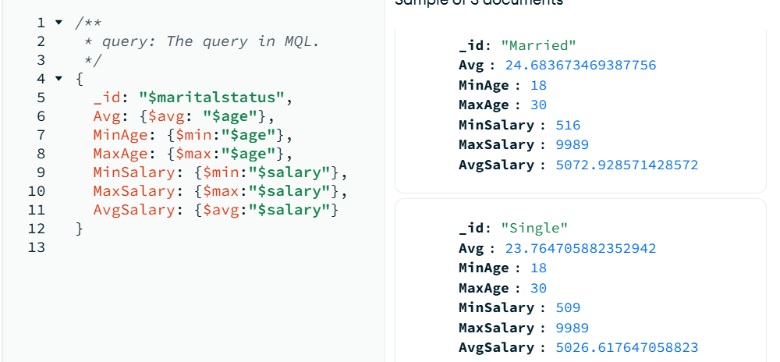

**Minimum and Maximum Salary of Male and Female.**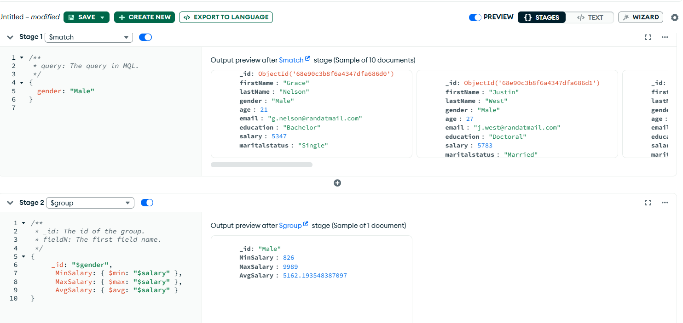

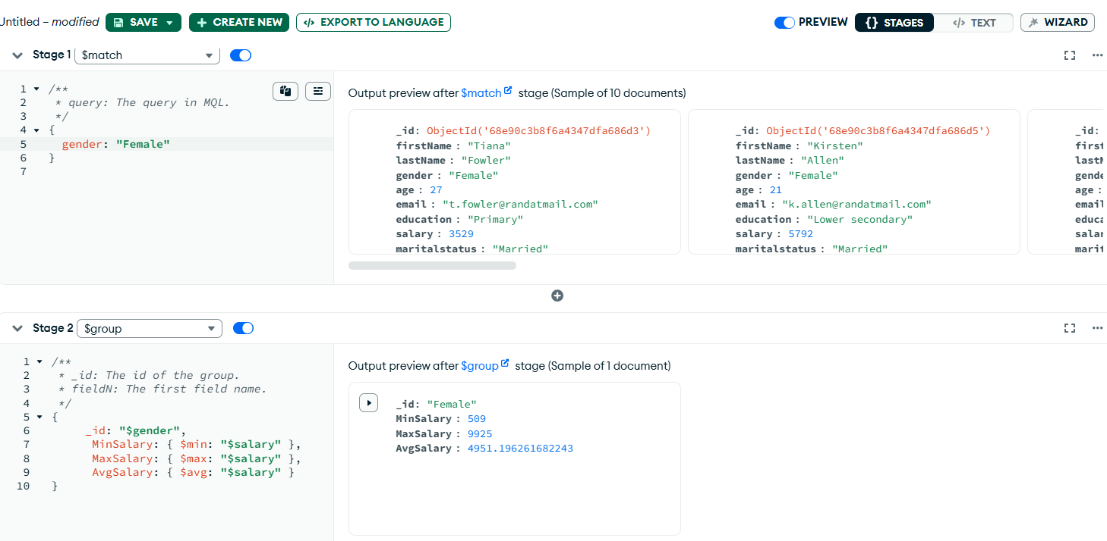

**Number of married and unmarried Males and Females.**